English II Academic Syllabus 2017/18

Susan Grimaldi
Room 125
sgrimaldi@rsu14.org
892-1810, ext. 2125
Afternoon hours: Monday and Wednesday, 2 – 3, and by appointment

Welcome to English II!

Essential Questions, which will guide our study.
- What is the common human experience?
- How is the human experience expressed in different cultures?
- How does self-knowledge help us recognize commonalities in other cultures?
- What impact do history and geography have on culture?
- How does literature reflect and perpetuate historical and cultural ideals?
WHS ELA Graduation Standards, which we will work toward over the course of the year. Link here for a complete list of 10th grade learning targets tied to the graduation standards
- Reading: Students will be able to comprehend complex texts and cite evidence to support analysis.
- Writing: Students will write informative/explanatory texts to examine and convey complex ideas, concepts, and information clearly and accurately.
- Argumentative Writing: Students will write thesis-driven arguments to support claims in an analysis of substantive topics or texts, using valid reasoning and relevant and sufficient evidence.
- Speaking and Listening: Students will participate effectively in a range of collaborative discussions as well as present information conveying a clear and distinctive perspective.
- Research Writing: Students will conduct research projects to solve problem, develop a position on an issue, or address a question.
- Language Usage; Students will demonstrate command of language, vocabulary, and conventions of standard English.
Texts
- Glencoe World Literature
- House on Mango Street, Sandra Cisneros
- Kite Runner, Khaled Hosseini
- Oedipus the King, Sophocles
- Things Fall Apart, Chinue Achebe
- The Tempest, William Shakespeare
- Folk Stories and Fairy Tales
- A selection of poems and shorts stories
- Vocabulary for the College Bound

Things you need to bring to class every day:
- Your charged MacBook
- A pen and/or pencil
- A binder or notebook that is for this class only
- Necessary text books
- Completed homework
- A sense of humor
- Intellectual curiosity

Five simple rules for success in this class:
- Be present, physically and mentally (NO cell phone use in class. Period.).
- Be on time.
- Be prepared – bring everything on the list above.
- Be kind – treat others respectfully, work with others cooperatively, listen to others attentively.
- Be curious.

Grading
Assignments are divided into two categories: formative and summative.
- Formative assignments include homework, such as vocabulary exercises, first drafts of essays, and in-class assignments that build and refine skills. These assessments will not be factored into quarter or final grades. However, it is very important that you complete all assignments on time. Formative assignments will be scored using the following scale:

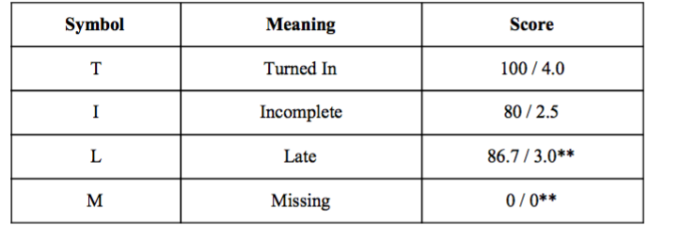
Please read the following information regarding formative assessments.
- Missing assignments will receive a grade of “0”. If a student is missing a formative assignment, it is the responsibility of the student to arrange a meeting with the teacher to receive feedback during a PRIDE block or after school. If the work is acceptable, the teacher can move the formative assessment grade on that assignment to a “3.0”. Formative assessments must be completed before the summative assessment is given.
- **Missing formative assignments may be turned in late for a score of an 86.7/3.0. These late assignments will be marked late and must be turned in before the summative assessment is given.

Summative assessments account for 100% of progress report, quarter, and final grades. Summative assessments include tests, quizzes, projects, presentations, and essays. Summative assessments are scored using the following rubric:
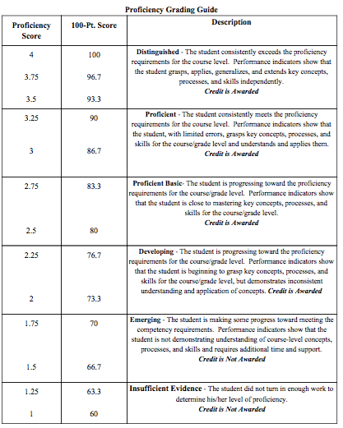
Please carefully read the following information regarding summative assessments.
- If a student does not demonstrate proficiency on (Score of 2.0) or has missed the deadlines for a summative assessment (unit tests, final papers, projects, etc.), he/she may make up a summative assessment under the following conditions:
a) The student has maintained a formative assessment score of 2.5 or higher prior to the assessment.
b) The student will conference with the teacher to develop a reasonable timeline for reassessment and the body of work that the student must demonstrate in order to show readiness for reassessment. The student must hand in the work by the due date established.
- The student may reassess only to a basic proficiency score of 2.5 but cannot receive a higher score for that assessment.
Online resources: You will set up accounts in class for the first three and you must have them bookmarked. We will review theses resources the first two days of class.
- Google Classroom
- Turnitin
- Noodle Tools
- Canva
- Thinglink

I am looking forward to working with you this year. If you have any questions or concerns about this class, please make time to speak with me about your concerns.

