Satire: Comedy and Culture Syllabus 2017/18

Susan Grimaldi
Room 125
sgrimaldi@rsu14.org
892-1810, ext. 2125
Afternoon hours: Monday and Wednesday, 2 – 3, and by appointment

WHS ELA Graduation Standards, which we will work toward over the course of the year. Link here for a complete list of 11th and 12th grade learning targets tied to the graduation standards
- Reading: Students will be able to comprehend complex texts and cite evidence to support analysis.
- Writing: Students will write informative/explanatory texts to examine and convey complex ideas, concepts, and information clearly and accurately.
- Argumentative Writing: Students will write thesis-driven arguments to support claims in an analysis of substantive topics or texts, using valid reasoning and relevant and sufficient evidence.
- Speaking and Listening: Students will participate effectively in a range of collaborative discussions as well as present information conveying a clear and distinctive perspective.
- Research Writing: Students will conduct research projects to solve problems, develop a position on an issue, or address a question.
- Language Usage; Students will demonstrate command of language, vocabulary, and conventions of Standard English.

Course Overview
Satire can be defined as “a technique employed by writers [or other artists] to expose and criticize foolishness and corruption of an individual or a society by using humor, irony, exaggeration or ridicule. It intends to improve humanity by criticizing its follies and foibles” (literarydevices.net). In this course, students will examine a wide range of cultural, political, and social satire, from Chaucer’s Canterbury Tales to SNL and Family Guy. We will analyze the use of satire and satirical devices in films, literature, music, television, stand-up comedy, and graphic texts. Students will create at least one original work of satire.

Major summative assessments will include
- A notebook that contains a variety of satirical works that address one particular theme
- A critical essay in which you will analyze one or more satirical works
- A creative project for which you will create a work of satire that demonstrates your understanding of satirical devices and the purpose of satire

Things you need to bring to class every day:
- Your charged MacBook
- A pen and/or pencil
- A binder or notebook that is for this class only
- Necessary text books
- Completed homework
- A sense of humor
- Intellectual curiosity

Five simple rules for success in this class:
- Be present, physically and mentally (NO cell phone use in class. Period.).
- Be on time.
- Be prepared – bring everything on the list above.
- Be kind – treat others respectfully, work with others cooperatively, listen to others attentively.
- Be curious.

Texts and Resources:
Excerpts from Chaucer’s Canterbury Tales
“A Modest Proposal” by Swift
The Importance of Being Earnest, Oscar Wilde
A satirical novel of student’s choice (list of suggested titles will be provided)
The Lego Movie
Dr. Strangelove , This is Spinal Tap, Monty Python and the Holy Grail, Blazing Saddles or some other classic satirical film (class choice)
The Onion
McSweeney's Internet Tendency
Mad Magazine
Daily Show, SNL, Simpsons, and many other modern satirical television shows
Political cartoons
A wide variety of satirical works by cartoonists, photographers, painters . . .

Grading
Assignments are divided into two categories: formative and summative.
- Formative assignments include homework, such as vocabulary exercises, first drafts of essays, and in-class assignments that build and refine skills. These assessments will not be factored into quarter or final grades. However, it is very important that you complete all assignments on time. Formative assignments will be scored using the following scale:

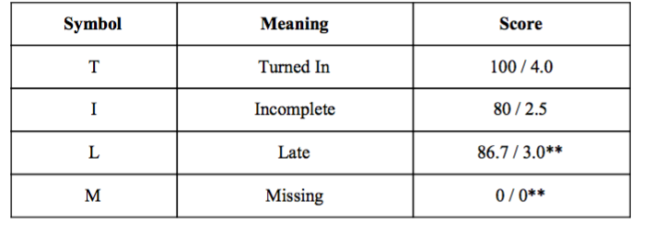
Please read the following information regarding formative assessments.
- Missing assignments will receive a grade of “0”. If a student is missing a formative assignment, it is the responsibility of the student to arrange a meeting with the teacher to receive feedback during a PRIDE block or after school. If the work is acceptable, the teacher can move the formative assessment grade on that assignment to a “3.0”. Formative assessments must be completed before the summative assessment is given.
- **Missing formative assignments may be turned in late for a score of an 86.7/3.0. These late assignments will be marked late and must be turned in before the summative assessment is given.

- Summative assessments account for 100% of progress report, quarter, and final grades. Summative assessments include tests, quizzes, projects, presentations, and essays. Summative assessments are scored using the following scale:
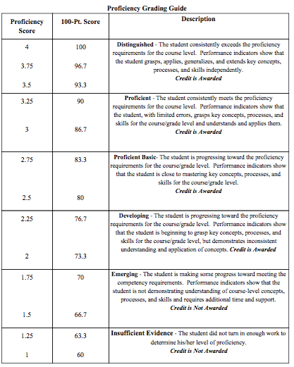

Please carefully read the following information regarding summative assessments.
- If a student does not demonstrate proficiency on (Score of 2.0) or has missed the deadlines for a summative assessment (unit tests, final papers, projects, etc.), he/she may make up a summative assessment under the following conditions:
a) The student has maintained a formative assessment score of 2.5 or higher prior to the assessment.
b) The student will conference with the teacher to develop a reasonable timeline for reassessment and the body of work that the student must demonstrate in order to show readiness for reassessment. The student must hand in the work by the due date established.
- The student may reassess only to a basic proficiency score of 2.5 but cannot receive a higher score for that assessment.
Online resources: You will set up accounts in class for the first three and you must have them bookmarked. We will review theses resources the first two days of class.
- Google Classroom
- Turnitin
- Noodle Tools
- Canva
- Thinglink

I am looking forward to working with you this year. If you have any questions or concerns about this class, please make time to speak with me about your concerns.

